**Building A Digital Hourglass**

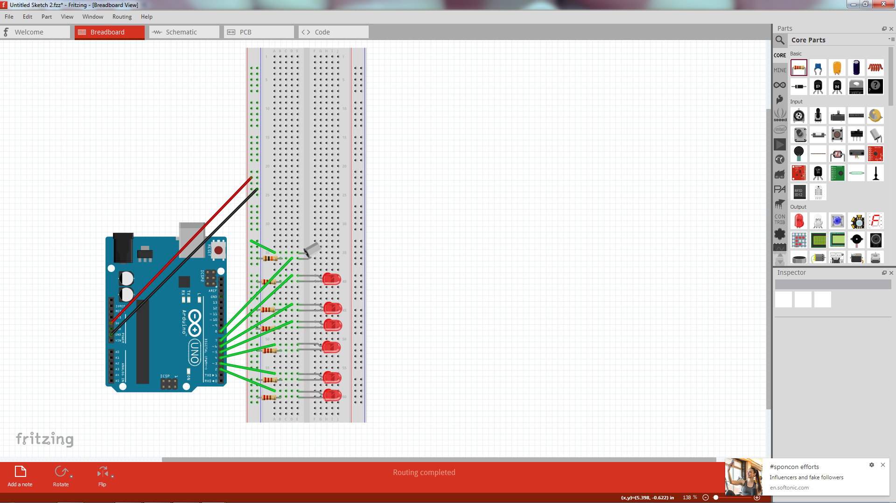

**The Code**

//Declare variables

const int switchPin = 8;

unsigned long previousTime = 0;

int switchState = 0;

int prevSwitchState = 0;

int led = 2;

long interval = 600000;

void setup()

{

//Set pins 2 to 7 to OUTOUT

for(int x = 2;x<8;x++){

pinMode(x, OUTPUT);

}

//Set pin 8 to INPUT

pinMode(switchPin, INPUT);

}

void loop(){

unsigned long currentTime = millis();

//Cycle through the LED’s turning them on one at a time

if(currentTime - previousTime > interval) {

previousTime = currentTime;

digitalWrite(led, HIGH);

led++;

if(led == 7){

}

}

//Check to see if hourglass has been reset

switchState = digitalRead(switchPin);

//Reset LED’s to off

if(switchState != prevSwitchState){

for(int x = 2;x<8;x++){

digitalWrite(x, LOW);

}

led = 2;

previousTime = currentTime;

}

//Allow the hourglass to start functioning again

prevSwitchState = switchState;

}